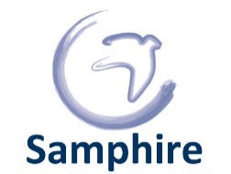
Equality information form
The information you share with us about your identity is anonymous and voluntary. We use it to reduce discrimination and improve our services. This information will have no impact on the service you receive from Samphire. If you do not want to answer any of the questions please tick you would ‘prefer not to say’ or cross it out. Many thanks.
1. What is your ethnic group or race?
Choose one option that best describes your ethnic group or background, describe any other ethnic group, or state you’d prefer not to say
Asian/ Asian British
Bangladeshi Chinese Indian Pakistani
Another Asian background or more detail you want to share I’d prefer not to say
Black/ Black British
AfricanBlack British Caribbean
Another Black background or more detail you want to share I’d prefer not to say
Mixed/ Multiple ethnic groups
Asian and WhiteBlack African and White Black Caribbean and White
Another mix of backgrounds or more detail you want to share I’d prefer not to say

Other groups
Arab Persian Jewish
Any other background or more detail you would like to share I’d prefer not to say
White
British English Gypsy Irish Irish Traveller Kurdish Roma Northern Irish Scottish Welsh
Another White background or more detail you would like to share I’d prefer not to say
2. What is your nationality and status?
What is your nationality? Please tell us about your nationality or nationalities if you hold more than one passport or if you are currently stateless. Please tell us about your immigration status. Please tell us about the languages you speak.
What was your country of birth? I’d prefer not to say

Nationality or nationalities Stateless I’d prefer not to say
Are you a British subject or what is your immigration status? I’d prefer not to say
What languages do you speak? I’d prefer not to say

3. What is your age?
How old were you on your last birthday? I’d prefer not to say

4. What is your sex?
This question is about the sex doctors assigned at birth. A question about your gender follows.
FemaleIntersexMale I’d prefer not to say
5. What is your gender?
Cis FemaleIntersexCis MaleNon-binary Trans FemaleTrans Male
Another gender identity or more detail you would like to share I’d prefer not to say

6. Are you disabled?
Do you have a long term health or mental health need that impacts on your day to day life?
Yes No I’d prefer not to say
What are your access needs or the ‘reasonable adjustments’ that remove the barriers that make you disabled?

7. What is your sexuality?
Bisexual HeterosexualHomosexual Lesbian
Any other sexuality or more detail you would like to share I’d prefer not to say

8. What is your faith or religion?
Atheist BuddhismChristian Hindu Jewish Muslim Sikh
Any other belief, faith or religion you subscribe to or more detail you would like to share I’d prefer not to say

9. Are you married, divorced or single?
Civil PartnershipDivorcedMarriedSingle
Any other relationship status or more detail you would like to share I’d prefer not to say
10. Are you pregnant or on maternity leave?
Yes No I’d prefer not to say

Samphire is committed to confidentiality and holds data following data protection law.
The categories used on this form follow the protected characteristics in Equality Act 2010 and were used by the Office of National Statistics during the 2021 census. Some have been improved or made more detailed as a result of Samphire’s Expert by Experience and frontline knowledge of the communities with whom we work and our expertise on and commitment to human rights and social justice.

We welcome feedback and questions about this form and all aspects of our work.

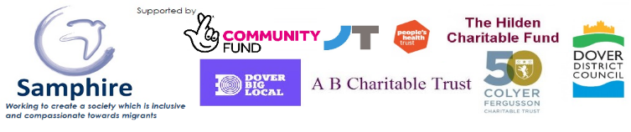
Patron: Bishop Rose Hudson-Wilkin
54-56 Castle Street, Dover, Kent, CT16 1PJ
Telephone: 01304 242755
www.SamphireProject.org.uk
Registered Charity No. 1106667
Regulated by the OISC. Ref. No N201800024

