10.30-11.30 Registration, networking, Tea & Coffee

11.30-11.35 Welcome & Housekeeping
Mhairi McGhee Director of Samphire

11.35-11.45 Introduction to Samphire, History & Overview of the Post Detention Project
Indre Lechtimiakyte, Legal & Migrant Support Manager
Post Detention Support Project Staff

11.45-12.00 Spoken word/Poetry performer
Miss Jacqui

12.00 – 12.15 Immigration system and Mental Health
Migrant Organise – Brian Dikoff

12.15 – 12.30 Legal Support (Access & Regulated Advisors)
Refugee Action – James Conyers

12.30 – 12.45 Uncomfortable Conversations
Joint Council for the Welfare of Immigrants (JWCI)

12.45 – 1.00 A word from Samphire’s Steering Group
Lucy – Reading poem (5mins)
Aissata – Reading a self-written piece (5mins)
Diana – Singing/Speech (5mins)

1.00 – 1.15 Music by Hear Me Out

1.15 – 2.15 Lunch Break

2.15 - 3.15 Workshops:
Workshop 1 Mental Health & Well Being – MIND Brent, Wandsworth and Westminster (max 20)

Workshop 2 Telling Your Story for the Change You Want - Migrant Voice (max 20)

Workshop 3 Creative Writing – Shazea Quraishi – Poet & Trustee of English Pen

Workshop 4 NHS Charges & Unpaid Bills - Doctors of the World National Health Advisors

3.15 – 3.30 Short Break & Reconvene in Main Auditorium

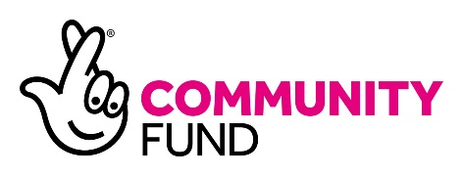
3. 30 – 4.30 Open floor, panel discussion and closing remarks.

